PHYSICS LECTURE NOTE SS1

PHYSICS SSI SCHEME OF WORK (FIRST TERM)

1. Introduction to Physics, Economics importance of Physics, Scholar and achievement in the field of physics
2. Measurement (length, mass, weight, time and electric charge), Fundamental and derived quantity, Dimensional analysis/ Concept of Time
3. Motion( Definition, types, causes ), Circular motion, centripetal and centrifugal forces
4. Friction : Types, Laws of frictions, Advantages and disadvantages
5. Position: Distance, displacement, speed, velocity, Distance-time graph
6. Rectilinear acceleration( uniform and non-uniform), velocity – time graph
7. Density, relative density
8. Upthrust, Archimedes’ principle, law of floatation, Pressure
9. Work, Energy and Power
10. Viscosity : Definition, effect, terminal velocity
11. Revision/Examination

WEEK 1: INTRODUCTION TO PHYSICS

Physics is defined as a branch of science that study matter and energy interaction.

BRANCHES OF PHYSICS

They include the following

1. Mechanics ( kinematics and dynamics)
2. Thermodynamics
3. Waves
4. Sound
5. Electricity
6. Magnetism
7. Optics
8. Nuclear and Atomics physics

Physics can be classified into two major branches, which are:

1. Classical physics- before the 20th century (B) Modern Physics – beginning of 20th century  
   ECONOMIC IMPORTANCE OF PHYSICS
2. It extends and enhances our understanding of other disciplines eg agricultural etc – which is important to all people of the world.
3. It improves the quality of our life by providing the basic understanding necessary for developing new instrumentation and techniques for medical application etc
4. It is an important element in education of chemists, engineers and computer scientist
5. It generate fundamental knowledge needed for future technological advances that will empower economic growth.

ASSIGNMENT

|  |  |
| --- | --- |
| Name of scientists | Achievement in the field of physics |
|  |  |
|  |  |
|  |  |
|  |  |

WEEK 2: MEASUREMENT

Measurement of matter has always been very useful to people in measuring distance, building houses and weighing goods.

Class Discussion: Why is measurement very important in physics? (ii) types of system of measurement: metric system, English or imperial system

**Systems of Units**

A system of units is the complete set of units, both fundamental and derived, for all kinds of physical quantities. The common system of units which is used in mechanics are given below

**1.CGS System** In this system, the unit of length is centimetre, the unit of mass is gram and the unit of time is second.

2. **FPS System** In this system, the unit of length is foot, the unit of mass is pound and the unit of time is second.

3. **MKS System** In this system, the unit of length is metre, the unit of mass is kilogram and the unit of time is second.

4. **SI System** This system contain seven fundamental units and two supplementary

fundamental units.

Fundamental Quantities: these are quantities that are independent of other quantities.

Fundamental Units : these are units of fundamental quantities or units that are independent of other units

|  |  |
| --- | --- |
| Quantity | unit |
| Length | Metre(m) |
| Time | Second(s) |
| Mass | Kilogram(kg) |
| Temperature | Kelvin(K) |
| Amount of substances | Mole(mol) |

Derived Quantities: quantities that are dependent of other quantities

Derived Unit: units of derived quantities

|  |  |
| --- | --- |
| Derived quantity | Unit |
| Area | metre square (m2) |
| Volume | metre cube(m3) |
| Velocity | metre/second(ms-1) |

SUB-MULTIPLE AND MULTIPLE UNITS

|  |  |  |
| --- | --- | --- |
| Multiple | Prefix | Symbol |
| 1012 | tera | T |
| 109 | giga | G |
| 106 | mega | M |
| 103 | kilo | k |
| 102 | hecto | h |
| 101 | deca | da |

|  |  |  |
| --- | --- | --- |
| Sub-multiple | Prefix | Symbol |
| 10-12 | pico | p |
| 10-9 | nano | n |
| 10-6 | micro | μ |
| 10-3 | milli | m |
| 10-2 | centi | c |
| 10-1 | deci | d |

DIMENSIONAL ANALYSIS

It shows the relationship between different basic or physical quantities.It involves reducing a complex quantity. It involves the use of L, M and T for length, mass and time respectively.

************ solved Examples****************

DO NOT WRITE:

Practise work: Find the dimension of the following density, work, impulse power, force, velocity

PRACTICAL SECTION: how use to; {See MV Sample sheet , worksheet 1 and 2}

1. Use of micrometer screwguage
2. Use of vernier caliper
3. Spring balance
4. Digital beam balance
5. Stop clock/watch
6. Practical on measurement : see site http://practicalphysics.org/measuring-mass-length-and-time.html

ASSIGNMENT (LENGTH)

|  |  |  |
| --- | --- | --- |
| instrument | Measuring accuracy | Used to measure |
| Metre rule |  |  |
| Vernier caliper |  |  |
| Micrometer screwguage |  |  |

LENGTH :

This is the distance between two points. The SI unit is metre. The above instruments are used to measure length.

TIME:

Time is defined as that in which events are distinguishable with reference to before and after. The SI unit is second(s). Throughout history, various devices of increasing accuracy have been used to measure time.

Ancient method :

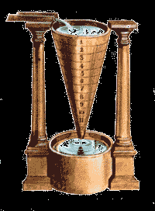

Egyptian water clock : The water clock was a clock commonly used in ancient and medieval times. It works by maintaining a steady flow of water.

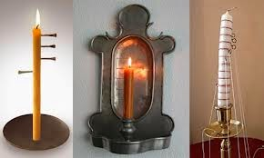

Candle clock: Candles are simple time-telling devices which work simply by burning at a fixed rate. To indicate the time, candles are marked with hours.

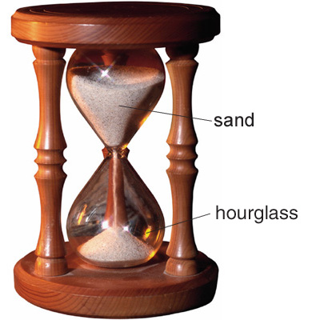

Hour glass: The hourglass tells time roughly in terms of an amount of sand which pours through a small hole at a nearly fixed rate. As the name implies, the sand in most hourglasses pours for one hour. Egg timers, which run out in 3 to 5 minutes, are small versions of hourglasses.

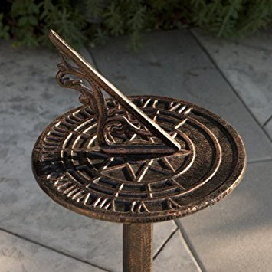

Sundial: The sundial was invented in ancient Egypt and was also used in ancient China, Greece, and Rome. Sundials consist of a shadow-maker known as a gnomon, which casts a shadow onto a surface below, usually marked with the hour. As the sun moves through the sky, the shadow moves accordingly, indicating the time of day.

Modern method :  
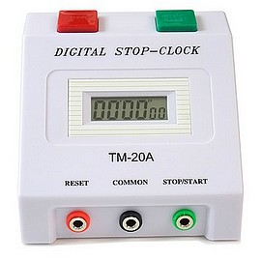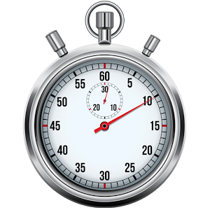

stop clock/watch (analog/digital),

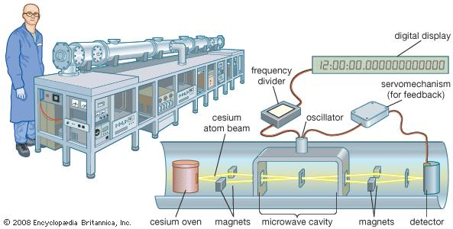Atomic clock: The atomic clock is the most accurate clock currently in use. This led to the internationally agreed definition of the second being based on atomic time.

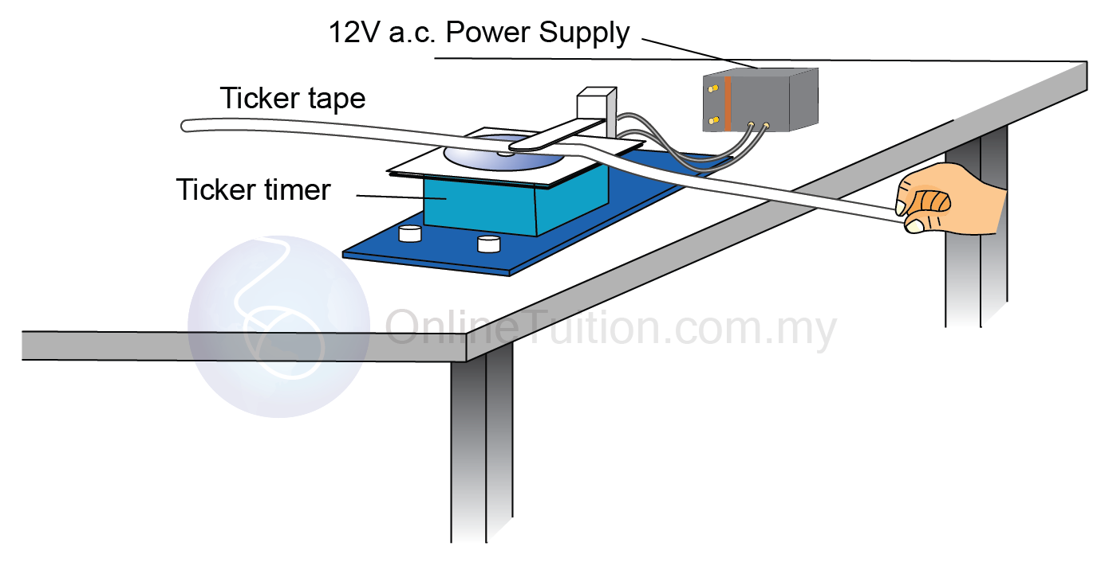

Ticker-tape timer: The ticker timer makes dots on a paper tape every fiftieth of a second. So if a piece of tape is pulled through the timer for a second there will be 50 dots on it.

VOLUME  
Deals with capacity or quantity of liquid. The volume of a regular solid can be obtained using a standard formula while that of an irregular solid can be determined using the displacement method. The volume of liquid is measured using a measuring cylinder.

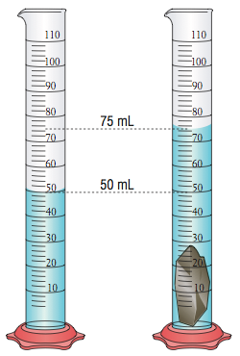 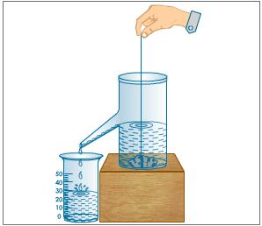

Mass

Mass is the amount of matter in an object. The SI unit is in kilogram (kg). It can be measured using the following :

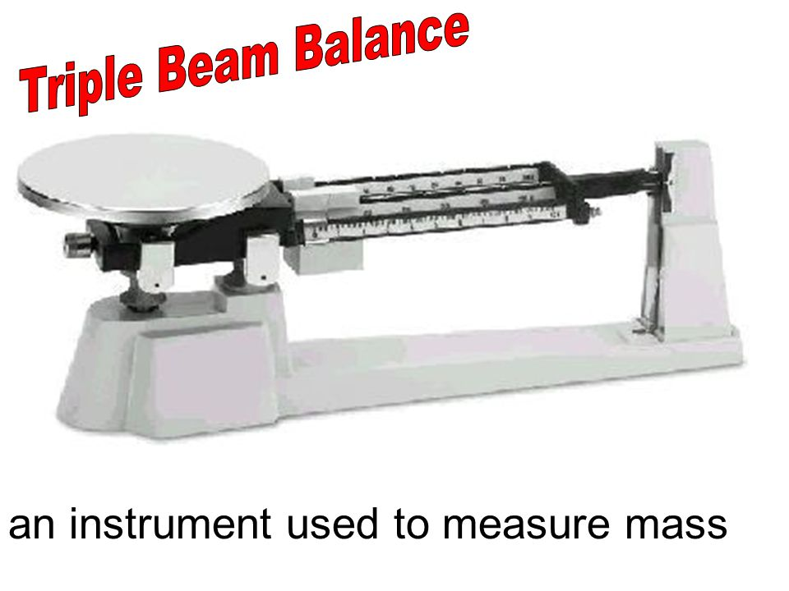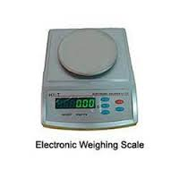

CLASS DISCUSSION:

1. On the old methods of measuring time
2. State 3 differences between mass and weight.
3. Conversion between sub-multiple and multiple units [ convert 2dm , 4mm, 3cm, 5 μm to metres]
4. In a tabular form list 3 (each) for measuring length, time and mas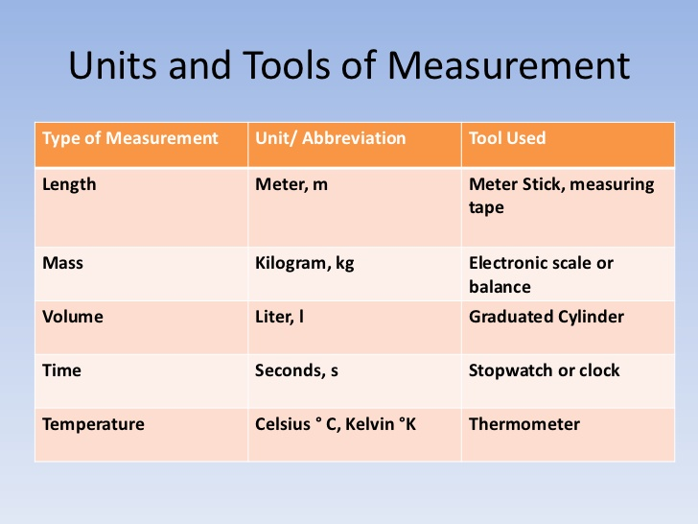

WEEK 3: MOTION

Motion is defined as the change in position of an object with respect to time. The study of motion without regard to the forces or energies that may be involved is called kinematics. It is the simplest branch of mechanics. The branch of mechanics that deals with both motion and forces together is called dynamics

TYPES OF MOTION

1. TRANSLATIONAL/RECTILINEAR : movement of the whole body from one point to along a straight path
2. ROTATIONAL: The turning of a body about a fixed point.The main **difference between** circular motion and rotational **motion** is that **circular motion** is a special case of **rotational motion**, where the distance **between** the body's centre of mass and the axis of **rotation** remains fixed. **Rotational motion** is based around the idea of **rotation** of a body about its center of mass
3. OSCILLATORY /VIBRATORY: to and fro movement about a central position
4. RANDOM: irregular movement which follows no definite pattern.

N.B: Objects in motion often exhibit more than one type of motion at the same time

PRACTICE: List 2 examples each for the above types of motion mentioned before

RELATIVE MOTION: This is the motion of one body /object with respect to a second body.

Frame of reference: the object that is being used as a point of reference. To determine the relative velocity of an object with respect to a frame of reference.

* If two bodies A and B are moving in straight line and same direction with velocity VA and VB, then the relative velocity of A with respect to B is VAB= VA - VB

* If two bodies A and B are moving in straight line in opposite direction, then VAB= VA + VB

*Practice questions worksheet 3 – relative/ Rel Vel QA*

IMPORTANT: When the objects are travelling in same direction, you subtract, in opposite direction

N.B: Objects in motion often exhibit more than one type of motion at the same time

CAUSES OF MOTION:

Force is responsible for motion. Force is defined as an action that changes the state of rest or uniform motion of a body.It is given by

Force = ma (or F = mg).

TYPES OF FORCE

|  |  |
| --- | --- |
| Contact force | Force field or Non-contact |
| Examples push, pull, tension, friction | Electrostatics force, gravitation, magnetic, electric force |

CIRCULAR MOTION

**Circular motion** is a movement of an object along the circumference of a circle or rotation along a **circular** path.

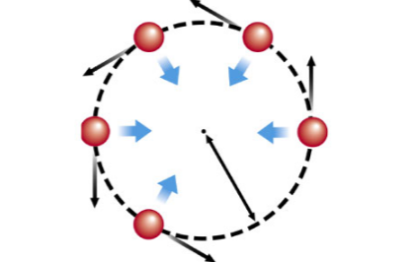

APPLICATION:  
1. In centrifugal dryers (in washing machine)  
2. Centrifuge for separating suspended solid material from liquid   
3. It keeps vehicles travelling round curves from topping

An object moving with a constant speed along a circular path is said to have a uniform circular motion.

Some examples of circular motion are:

i. The earth moving round the sun

ii. The motion of the moon round the earth.

iii. A stone tied to a string and whirled in a horizontal or vertical circle.

iv. The satellite circling round the earth.

v. The planets moving round the sun.

The speed of an object moving round a circle is constant in magnitude but its direction changes in uniform manner. Therefore, the velocity and acceleration of the object also change with time.

Two forces are known to act on an object moving in a circular path. There are:

(a) Centripetal forces

(b) Centrifugal forces

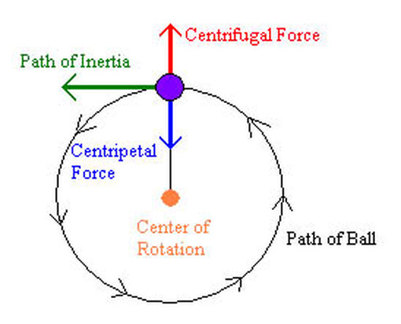

**Centripetal Force**is the inward force that tends to push the object towards the

centre of the circle. It is the force required to keep the object moving with constant

speed in a circular path. As a result of this force, the object is accelerated towards the centre of the circle with acceleration given by

a =v2/r

where v = Velocity of the object, r = radius of the circular path, a = Centripetal acceleration

Since force, is given by F = ma

:. The centripetal force pushing the object towards the centre of the circle is

Fcp = mv2/r

Where m = mass of the object

**Centrifugal Force** acts in opposite direction to the centripetal force. It acts in such a way that it tends to push the object away from the centre of the circle. Thus, the

centripetal force and centrifugal forces keep the object moving round the circular

path.

Centrifugal force is given by Fcf = - mv2/r

**Applications Of Centrifugal Force**

 A person driving a car experiences the effect of centrifugal force as the car turns a corner.

 The effect of centrifugal force is also applied when centrifuge is used to separate particles from liquid in which they are suspended.

 The centrifuge is also used in medical field to separate various solid constituents of blood which have different mass densities.

 In centrifugal dryers (in washing machine)

**Relationship Between Angular Velocity (ω) and Linear Velocity (v).**

Consider the motion of an object in a circular path

******** Fig. 3. The motion of and object in a circularpath leave 4 lines*****

Angular velocity (**ω**) is defined as the angle turned through (𝜃), divided by the time

taken.

i.e. Angular velocity **ω** =

**ω**=

**ω** is measured in radians while time t is measured in seconds, therefore, the units of **ω** is radians per second (rads-1)

ϴ = **ω**t (radians)

The corresponding linear velocity is given by:

Linear velocity v =

**V** = where s = length of arc AB

Also ϴ =  s = ϴ r

**V** = = **ωr ( since ω**= **)**

:. V = 𝛚r ---- the relation between linear and angular velocities.

***Note***:

We can compare angles expressed in degrees and in radians, such

that 3600 = 2𝜋 radians

 1800 = 𝜋 radians

 900 = 𝜋/2 𝑟𝑎𝑑𝑖𝑎𝑛𝑠, 𝑒𝑡𝑐.

*****PRACTICE WORK/ calculation on centripetal force* // 3 differentiate between centripetal and centrifugal force

WEEK 4 : FRICTION {see ppt on friction first}

**Friction:**

Friction is defined as a force that opposes motion between two surfaces in contact. It does not appear unless there is a relative motion. Friction is equal to the applied force that tends to move a body at rest .It increases with the applied force.

Types of Friction

(a) Static or limiting friction: is the maximum force that must be overcome before a body can just start to move over another.

(b) Dynamic, Kinetic or sliding friction: When the block is pulled along so that it moves on the surface with uniform speed, the frictional force opposing the motion is known as sliding, kinetic or dynamic. Sliding friction is less than static friction. Therefore, kinetic or dynamic (sliding) friction is the force that must be overcome so that a body can move with uniform speed over another body.

LAWS OF SOLID FRICTION

* 1. It opposes motion between two surfaces in contact.
  2. Frictional force is directly proportional to the force which tends to start the motion
  3. It is dependent on the nature of the two surfaces in contact.
  4. It is independent on the area of the surfaces in contact
  5. It varies directly with the normal reaction ( f = *μR )*

**Advantages Of Friction**

Friction plays a vital role in our daily life. Without friction we are handicap.  
**1.** We cannot fix nail in the wood or wall if there is no friction.

**2.** A horse cannot pull a cart unless friction furnishes him a secure Foothold.  
3. We cannot write if there would be no friction between paper and the pencil.

**4.** Friction enables us to walk.

5. Friction is utilized in fan belts used over wheels or pulleys in machinery.

6. Friction enables the automobile tyres to make firm grip with the road

**DISADVANTAGES OF FRICTION**   
Despite the fact that the friction is very important in our daily life, it also has some disadvantages like:  
**1.**The main disadvantage of friction is that it produces heat in various parts of machines. In this way     some useful energy is wasted as heat energy.  
**2.** Due to friction we have to exert more power in machines.  
**3.** It opposes the motion.   
**4.** Due to friction, noise is also produced in machines.  
**5.** Due to friction, engines of automobiles consume more fuel which is a money loss.   
**METHODS OF REDUCING FRICTION**1. The use of lubricants like oil, grease, air and graphite can reduce friction.

2. The use of ball or roller bearings.

3. The streamlining of body shapes of moving objects.

**DESIGN MODIFICATION/streamlining:**Friction can be reduced by making the fast moving objects a streamline shape (fish shape). This causes the smooth flow of air and thus reduces air resistance at high speeds

**Acceleration of Block on Horizontal Smooth Surface.**

(1) **When a pull is horizontal**

*mg*

*R*

*m*

*F*

*a*

*R* = *mg*

and *F* = *ma*

∴ *a* = *F*/*m*

(2) **When a pull is acting at an angle (*θ*) to the horizontal (upward)**

*R* + *F* sin *θ* = *mg*

*mg*

*R*

*m*

*F* cos*θ*

*F*

*F* sin*θ*

*θ*

⇒ *R* = *mg* – *F* sin*θ*

and *F* cos*θ = ma*

∴ 

(3) **When a push is acting at an angle (*θ*) to the horizontal (downward)**

*R* = *mg* + *F* sin*θ*

*F* sin*θ*

*R*

*m*

*F* cos*θ*

*a*

*F*

*F*

*mg*

*θ*

and *F* cos*θ = ma*



**Acceleration of Block on Smooth Inclined Plane.**

(1) **When inclined plane is at rest**

*mg* cos*θ*

mg sin

**

*R*

*θ*

*mg*

*a*

*F*

Normal reaction *R* = *mg* cos*θ*

Force along a inclined plane

*F***=** *mg* sin*θ*

*ma = mg* sin*θ*

∴ *a = g* sin*θ*

(2) **When a inclined plane given a horizontal acceleration ‘*b*’**

Since the body lies in an accelerating frame, an inertial force (*mb*) acts on it in the opposite direction.

*mg* cos*θ* +*mb* sin*θ*

mg sin

**

*R*

*θ*

*mg*

*a*

mb cos

**

*θ*

*θ*

*b*

Normal reaction *R* = *mg* cos*θ* + *mbsinθ*

and *ma* = *mg* sin *θ – mb* cos *θ*

∴ *a* = *g* sin*θ* – *b* cos*θ*

**Angle of Friction or Coefficient Of Friction.**

Angle of friction may be defined as the angle which the resultant of limiting friction and normal reaction makes with the normal reaction.

*P*

*R*

*F*

*mg*

*θ*

*S*

By definition angle *θ* is called the angle of friction



∴ tan *θ* = *μ* [As we know  ]

or 

Hence coefficient of limiting friction is equal to tangent of the angle of friction

********solved question on friction – inclined and at rest*****

WEEK 5  
POSITION: DISTANCE, DISPLACEMENT, SPEED, VELOCITY, DISTANCE-TIME GRAPH

Direction: which way an object is oriented or moving within its coordinate system. Note that direction can be positive or negative.

Position(*s)*: the location of an object relative to the origin (zero point) of its coordinate system. We will consider position to be a zero-dimensional vector, which means it can be positive or negative with respect to the chosen coordinate system.

Distance (*d*): [scalar] how far an object has moved or the length between reference points.   
Displacement: [vector] Distance covered by a body in a specific direction. Displacement can be positive or negative (or zero), depending on the chosen coordinate system.

Speed: [scalar] the rate at which an object is moving at an instant in time. Speed does not depend on direction, and is always nonnegative.   
 Speed = …………………….m/s

Velocity: [vector] an object’s displacement over a given period of time. Because velocity is a *vector*, it has a *direction* as well as a *magnitude*. Velocity can be positive, negative, or zero. )

Velocity = …………………….m/s

**ACTIVITY (Speed v Time and Distance v Time Graphs)**Use the phrases below to describe the graphs. Each phrase may be used for more than one graph.Each graph should be described by several phrases.Constant speed, Stationary, Accelerating, decreasing speed, not moving

speed

f)

time

distance

a)

time

speed

i)

time

distance

h)

time

distance

g)

time

distance

e)

time

distance

d)

time

speed

c)

time

speed

b)

time



Similarity Between Velocity And Speed  
1. They have same unit m/s  
2. They are both used in measurement of distance

Differences

|  |  |
| --- | --- |
| Speed | Velocity |
| It is represented by s | It is represented by v |
| Speed = distance/time | velocity = displacement/time |

Graphs

This can be used to describe the nature of the motion of the object. They include:

1. Distance – time graph
2. Displacement - time graph
3. Speed – time graph
4. Velocity – time graph: This is the most useful of the graphs. The following information can be obtained from the velocity time graph include – Acceleration, retardation or deceleration, maximum speed or velocity and the total distance travelled.

RECTILINEAR ACCELERATION

Acceleration is the rate of change of velocity with time. If the rate of change of velocity with time is decreasing, it is said to be decelerating.

Acceleration = = =

N.B: Acceleration is increase in velocity while deceleration/retardation is decrease in velocity.

Uniform / non-uniform Acceleration:  
An object in motion has a uniform acceleration if its velocity increases by the same amount within equal time interval, no matter how small the time intervals may be while an object is said to have non-uniform acceleration if its velocity increases by different amounts within equal time intervals.

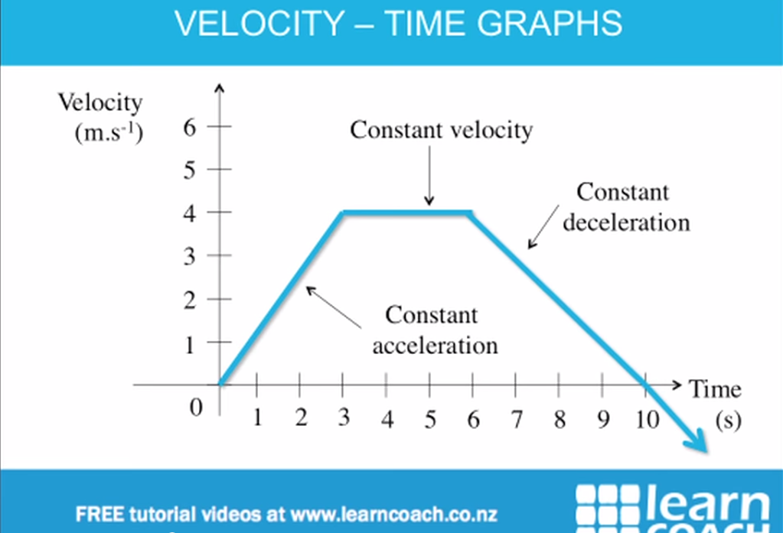

The total distance travelled is the area under the graph = area of the trapezium =

******SOLVED EXAMPLES :::*****************

WEEK 7: Density, Relative Density

Liquid and gases are called fluids. Fluids can flow unlike solids .  
Density is mass per unit volume of a substance

Density =

Relative Density

The density of pure water at 4°C is 1000kg/m3, hence the density of pure water is regarded as standard, hence relative density is defined as

R.D = = =

=

DETERMINATION OF DENSITY

1. Regular Shaped Solid : The density of regular shaped solid can be determined by first measuring the mass m of the solid using a chemical beam or lever balance. The volume of the solid is then found by measuring the dimension the dimensions of the solid ( l x b x h).   
   Density =
2. Irregular Shaped Solid : The mass of the solid is first obtained and its volume is determined by using displacement method. The volume of the displaced water is the volume of the solid

Density =

1. Liquid: To determine the density of a liquid, the mass m1 of the empty graduated flask is measure, then the flask is filled with the liquid to a definite graduation mark so as to obtain the volume v of the liquid. The mass m2of this filled graduated flask is then measured. The difference between the masses (m2 - m1) gives the mass of the liquid. The density is given by
2. Density =

The relative density of solid can be determined using a relative density bottle.

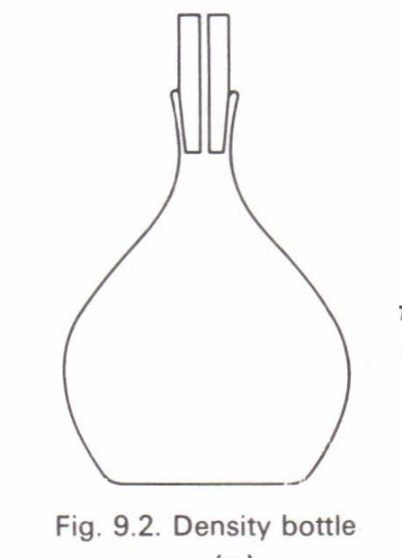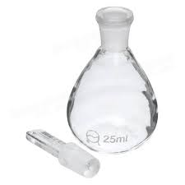

ASSIGNMENT: Briefly explain how to determine the relative density of (i) solid (ii) liquid.

**Applications of density.**

1. To calculate mass and weight of building materials to know the strength of supporting pillars and foundation.
2. Determining purity of liquids eg. Milk.

Hydrometer: is an instrument for measuring the relative density or density using principle of floatation.(What is a lactometer)

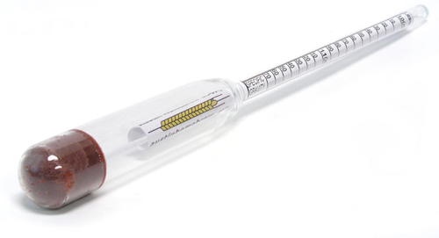

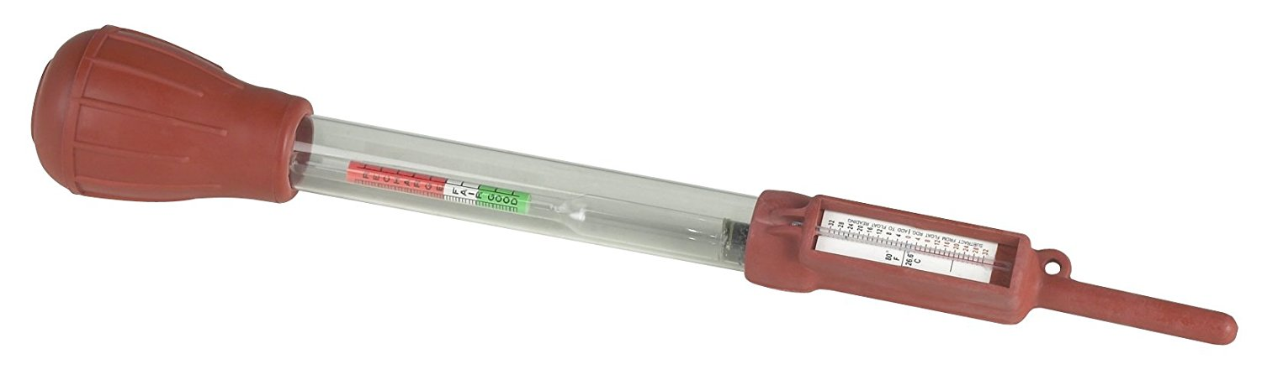

************* **SAMPLE CALCULATIONS on DENSITY, R.D, UPTHRUST\*\*\*\*\*\*\*\***

**ARCHIMEDES PRINCIPLE.**

Archimedes principle states that ‘’When a body is partially or totally immersed in water, it experiences an upthrust which is equal to the weight of liquid displaced.  
The weight of the body in air is greater than its weight when partially or totally immersed in water (liquid.)

The loss of weight when the body is partially or totally immersed in water is NOT actual loss. This loss is called apparent loss of weight, and weight of the body when immersed in water is called apparent weight.

Apparent weight or Upthrust of object in fluid = Weight in air – Weight in liquid.  
Upthrust of object in fluid = Weight of displaced fluid  
 = Mass of displaced fluid x g  
 = density of fluid x volume of object x g  
 = ρ x V x g

**PRINCIPLE OF FLOATATION.**

This is a special case of Archimedes principle. It states that an object will float when the upthrust exerted upon it by the fluid in which floats is equal to the weight of the body. Generally, an object floats in a liquid if its density is less than that of the liquid (i.e the solid displaces its own weight of the liquid).

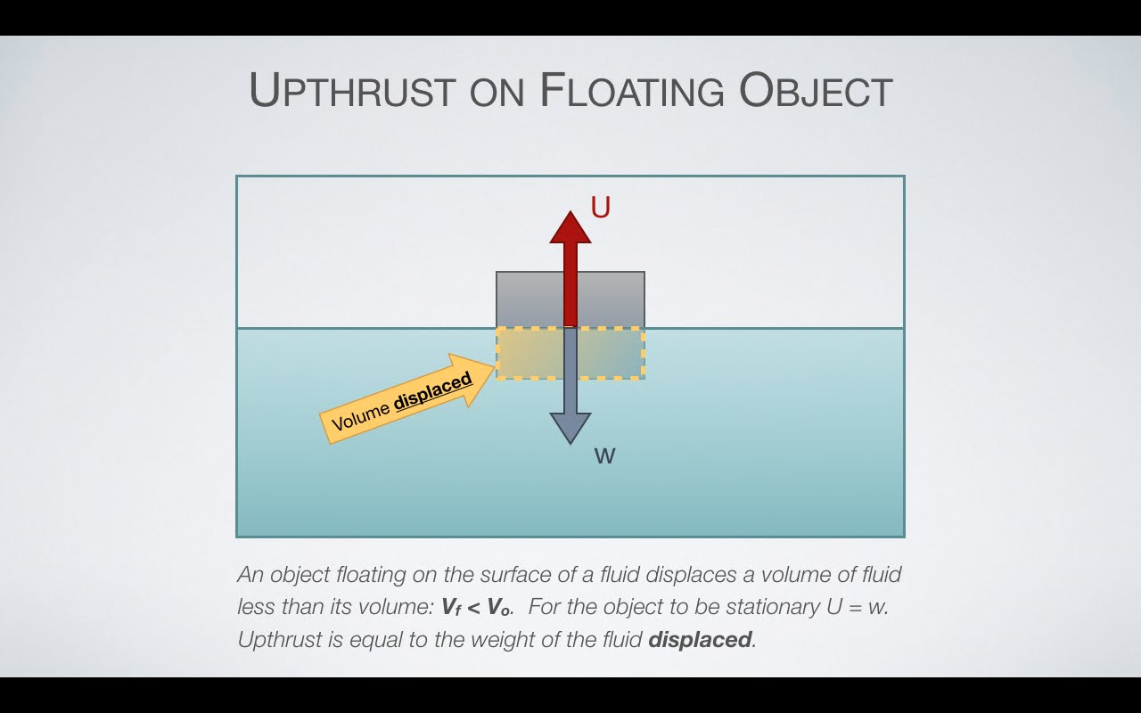

1. If W > U, the body will sink;
2. If W < U, the body will rise;
3. If W = U, the body will float.

PRESSURE

Pressure is defined as force per unit area  
Pressure = Nm-2

PRESSURE IN FLUID

Pressure in fluids (liquids or gases) depends on the depth (height) and density of the fluid.

Pressure = = = = =

Where P = pressure (N/m2), F = force(N), m = mass(kg), A = area(m2), ρ = density(kg/m3), (m/s2).

The properties of pressure in liquid are as follow:

1. The pressure at any point in a liquid is exerted equally in all direction.
2. The pressure is the same at all point on the same horizontal plane in a liquid.
3. The pressure at a point below the surface of a liquid directly proportional to the depth.
4. Pressure is independent of surface area in contact.
5. Pressure increases with density.
6. Pressure decreases with height.

ATMOSPHERIC PRESSURE

At sea level the atmospheric pressure is 760mmHg or 1.013 x 105 N/m2. Pressure reduces as you go higher into the atmosphere (above sea level) . Pressure increases as you go lower(below sea level);

A barometer is an instrument for measuring atmospheric pressure.   
A simple mercury barometer uses the height of a column of mercury to measure atmospheric pressure.

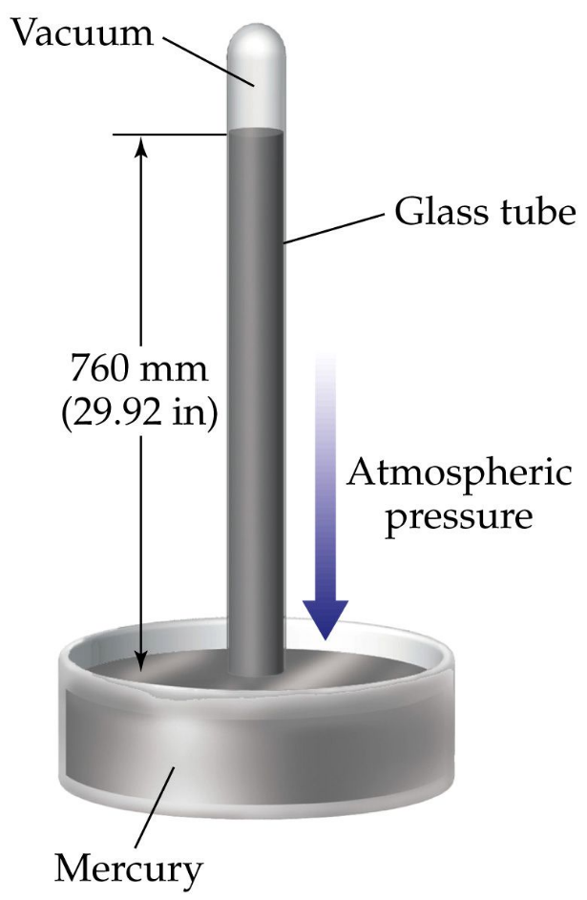

Aneroid barometer can also be used to measure liquid pressure. Isobars are lines on a map joining all points with same atmospheric pressure.

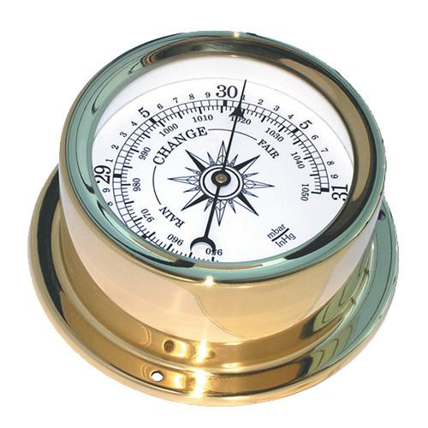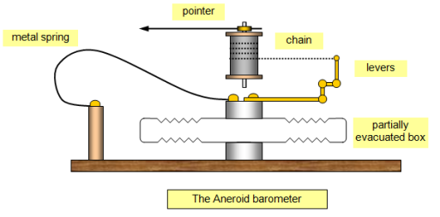

A manometeris a device used to measure the pressure of gases. It is a U-tube containing a column of liquid. The pressure of the gas measured by the manometer is

Pgas= Patm + hρg

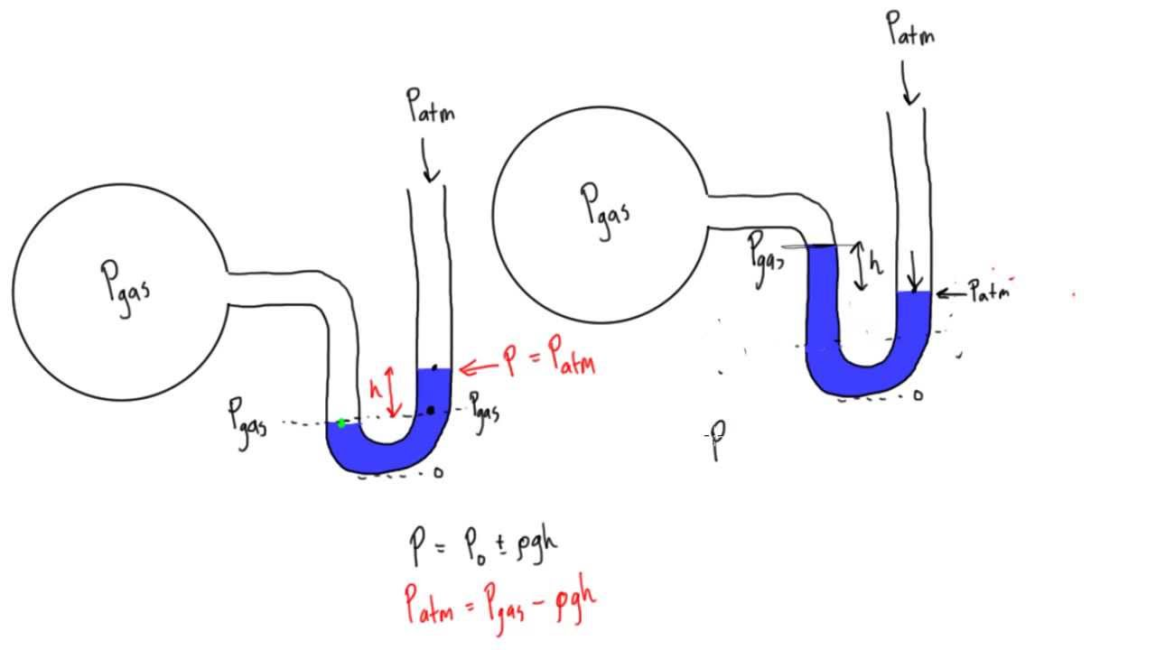

Applications of Atmospheric Pressure And Liquid Pressure  
1. Sucking.  
2. Syringe.  
3. Rubber sucking  
4. Siphon.  
5. Lift pump  
6. Force pump.  
7. Hydraulic press

************* **SAMPLE CALCULATIONS Pressure/manometer\*\*\*\*\*\*\*\***

ASSIGNMENTS: Briefly explain how the above mentioned instruments work base on the atmospheric pressure

WEEK 9: **WORK, ENERGY AND POWER**

Work is said to be done whenever a force moves an object (or body) through a certain distance in the direction of force, and is equal to the product of the force and the distance moved.

Thus, work is done when a box is dragged a certain distance or when a car moves a certain distance. In each of the examples, the value (amount) of work done is measured by the product of the force used and the distance moved in the direction of force.

Work = Force × distancemoved in the direction of force.

W=F x d………………………………(1)

The S.I unit of work is the joule J. Other units of work are kilojoule (kJ) and mega joule (mJ) such that,

1kJ = 1000 J or 103 J

1mJ = 1000000J or 106 J

***Note:***

If the object moved in a direction different from that of the applied force (i.e the force pulling it), then we first resolvethe force along the direction of motion. i.e.

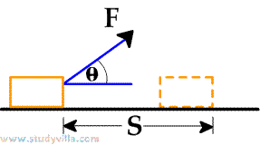

The work done in this case is given by:

W =Fcos× s ………………(2)

We have resolved using the trigonometric ratio

**Work Done In Force Field**

Case 1: **Lifting A Body**

Note: When a body is lifted vertically upwards, work is done against gravity. The work done is given by,

Work done = F × d

= mg× d

= mg × h…………………(3) where F = mg,

Where m = mass of the body, d= h = vertical distance, acceleration due to gravityg = 10m/s2

Case: 2 **Falling Bodies**

If a body of mass m falls through a vertical height h, the work done by gravity on the body is given by,

Work done = mg× h ………………….(3b)

**ENERGY**:

Energy is defined as the capacity to do work. Anything that is capable of doing work has energy.

TheS.I. unit of energy is the joule (J).

**Forms Of Energy**

(a) Mechanical energy which is divided into potential energy and kinetic energy.

(b) Heat energy

(c) Chemical energy

(d) Sound energy

(e) Solar energy

(f) Nuclear energy etc.

**Types of Mechanical Energy**.

(i) **Potential Energy (P.E)**

This is the energy possessed by a body due to its position [height]. A body of mass m raised to a height h, above the ground is said to possess potential energy whose magnitude is

Potential energy = work done

P.E = F x d

i.e. P. E= mg h

= mgd or mgh

Another example of potential energy is **Elastic Potential Energy**, which is the energy possessed by a stretched or compressed spring. The magnitude of this energy is given by

Elastic potential energy = ke2

Where k = elastic constant of the spring, *e* = distance through which the spring

is stretched or compressed.

(ii) Kinetic Energy [K.E]

This is the energy possessed by a body by virtue of its motion. The magnitude of this energy is given by

Kinetic energy = mv2

Where m = mass of the body, v = velocity of the body

**Transformation And Conservation Law Of Mechanical Energy**

The law of conservation of energy states that although energy can be converted from one form to another, the total energy of an isolated system remains constant.

Case1: **Energy Transformation Of A Falling Body**

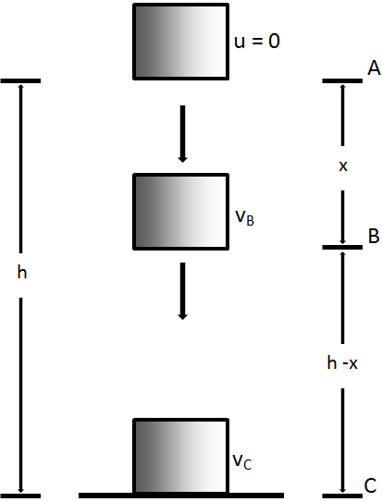

In general, the total energy of the object is

PE + KE at the top = PE + KE on the ground

i.e. PE + 0 at the top = 0 + K.E on the ground

i.e. PE = K.E

mgh = mv2 Conservation law of mechanical energy

Case 2: **Energy Transformation Of A Simple Pendulum**

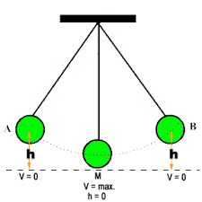

As the pendulum swings from A to B, the energy of the system changes from P.E to K.E and vice versa but at each stage of the swing; the total energy remains constant.

From the diagram above, we have the following:

(i) At A and B, P.E = mgh = maximum [because h is maximum] and

KE = 0 = minimum [ because v is minimum]

(ii) At C, K.E = mv2 = maximum [because v is maximum] andP.E = 0 = maximum[because h is minimum]

Since the total energy is always conserved

 K.E = P.E

mv2 = mgh

V*max*=√2𝑔ℎ

**Energy resources**

•**Renewable** source of energy: is inexhaustible, for example solar, hydroelectric, wind etc.

**Non**-**renewable** source of energy: is exhaustible for example fossil fuels

•**fuels** can be burnt (or nuclear fuel can be forced to decay) in thermal power stations to transform the chemical energy stored to thermal energy which makes steam which turns turbines (kinetic energy) to produce electricity

-advantage: cheap, plentiful, low-tech

-disadvantage: harmful wastes - produces greenhouse gases and pollutant gases, radiation...

•**hydroelectric dams**: river and rain water fill up a lake behind a dam. As water rushes down through the dam, it turns turbines which turn generators

**tidal power scheme**: a dam is built across a river where it meets the sea. The lake behind the dam fills when the tide comes in and empties when the tide goes out. The flow of water turns the generator.

-advantage: no greenhouse gases are produced

-disadvantage: expensive, can’t be built everywhere

•**wave energy**: generators are driven by the up and down motion of the waves at sea.

-advantage: does not produce greenhouse gases

-disadvantage: difficult to build

•**geothermal resources**: water is pumped down to hot rocks deep underground and rises as steam.

-advantage: no carbon dioxide is produced

-disadvantage: deep drilling is difficult and expensive

•**nuclear fission**: uranium atoms are split by shooting neutrons at them.

-advantage: produces a lot of energy from using very little resources

-disadvantage: producing radioactive waste

•**solar cells**: are made of materials that can deliver an electrical current when they absorb light energy

•**solar panels**: absorb the energy and use it to heat water

-advantage: does not produce carbon dioxide

-disadvantage: variable amounts of sunshine in some countries

**Power**

Power is defined as the time rate of doing work.

i.e. Power = =

Power =

Power= Force Velocity

Recall = = velocity (v), implying from (6) that power can also be expressed as

Power= Force Velocity

P = f x v

Also from P =

Recall F = mg

 Power P =

Where F= Force applied d = h = distance or height m = mass of the body

v =velocity of the body a = g = acceleration due to gravity

The S.I unit of power is the watt (W) or Joule per second (J/s). Other units of power are Kilowatt (kW) and megawatt (mW), such that

1 kW = 1000 W or 103W

1 mW =1000000 W or 106W

***Note:*** Power can equally be expressed in other units such as the horse power (h.p),

Where 1h.p =k W or 0. 75 kW.

Viscosity : Definition, effect, terminal velocity

viscosity is the internal friction between layers of a liquid or gas in motion.

Liquids which pour slowly are said to be more viscous than those which pour faster.

>>> What is viscostatic?

**Terminal velocity or speed**

Terminal velocity is the maximum velocity reached by a falling body when the sum of upward forces is equal to the weight of the body. A parachute falling freely under gravity attains a terminal velocity after it has fallen for sometime

A falling object through a viscous liquid is subject to three forces – namely:

i. Its weight (W) acting downwards.

ii. The upthrust (U) acting upwards.

iii. The viscous force (V = F )

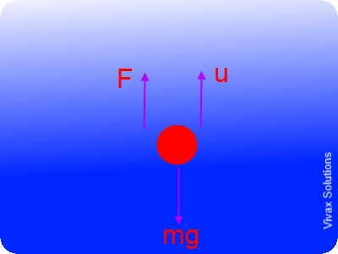

The equation of motion of the stone is given by

W - V – U = ma…………………………….(1)

Where a = acceleration of the stone in the liquid, m = mass of the stone

When the stone falls with constant velocity, a = 0, equation (1) then becomes

W - V – U = 0

∴ V = W – U ………………………………….(2)

